# Measuring Xbee temperature module current usage

Doug Leppard - May 4, 2013

## Setup

Use EEVBLOG ucurrent to measure current, it puts voltage output to scope.

Xbee using 3 AAA batteries updating temperature readings 1/sec.

## Scope output

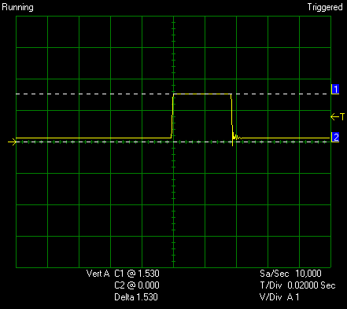

The graph above the scope voltage readings are 1.53 volts. This is when the XBee pulses on and transmits reading. That is 1530 micro amps.

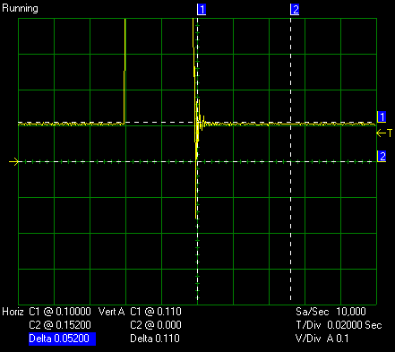

This is reading the steady state current usage. .11 V which is 110 micro amps continuous battery usage.

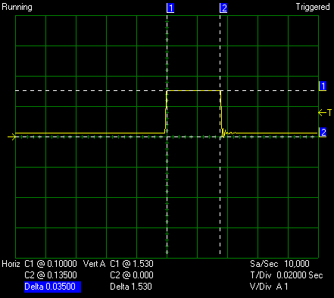

This graph shows the pulse power usage is .035 seconds or 35 ms.

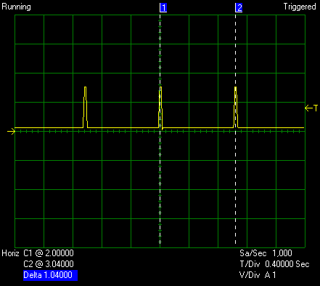

This graph shows it is firing every 1 second which it was set at.

So for this example the average current usage is 110 micro amps plus 54 micro amps (54 = (35ms/100ms)*1530).

If it was set to read every 15 second that would be 110 + 3.6 (54/15) = 114 micro amps.

Energizer battery at low current is 1200mah. So at reading every 15 seconds = 439 days or 1.2 years.

Additional comments

Without Xbee plugged in 1.5 mv which is 1.5 na

XBee plugged in when running at 1/sec

Has a spike that lasts 100 us and is 1.5ma = .000150 ma / sec * 3600 = .54 ma/hr

Then has a turn on time of 21.3 ms at 190 ua = 4,047 ua /1000/1000 = .004047ma/s * 3600 = 14.6 ma /hr

Then has transmit 13.8 ms at 870 ua = 12006/1000/1000 = .012 ma/s *3600 = 43.2ma/hr

Total 57.8 ma/hr

If at every 15 seconds = 3.9 ma/hr

Which is 307 hr or 13 days

Found this chart at <http://www.socgadget.com/2011/07/low-power-xbee-module/>

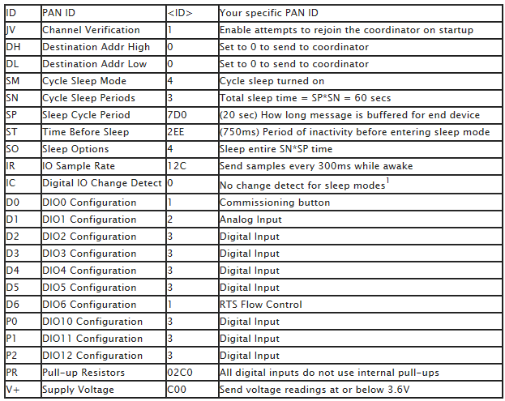

110 µA continuous

36ma(38ms/15000) = .084 ma or = 84 µa

If battery can hold charge 25 hours at 36ma, if with that drainage it would be 25hours*120/.038=

25 hours * 36ma = 900mah

1200mah/120ua = 416 days

1/411+1/416 = (1.012 + .98) = 411/1.99 = 206 days

3 days 4 days = 1/20 + 1/20

/827